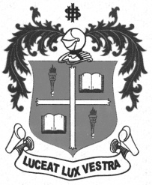
LOYOLA COLLEGE (AUTONOMOUS), CHENNAI – 600 034
M.A. DEGREE EXAMINATION - TAMIL LITERATURE
FIRST SEMESTER – NOVEMBER 2012

TL 1801 - MODERN LITERATURE

Date : 05/11/2012 Dept. No. Max. : 100 Marks

Time : 1:00 - 4:00



x=
- 
- 
- 
- 
- 

- 


 x=
- 

- 
- 

- 
- 
- 




 x=
- 
- 

- 

- 
*******

